**SPRINT 2**

|  |  |
| --- | --- |
| TEAM ID | PNT2022TMIDTMID44628 |
| PROJECT NAME | IOT BASED SAFETY GADGET FOR CHILD SAFETY AND MONITORING SYTEM |

OPEN THE IOT PLATFORM IN IBMCLOUD:

I am already enable the IOT platform in cloud.

Using this create a device with IOT Watson platform is successfully finished

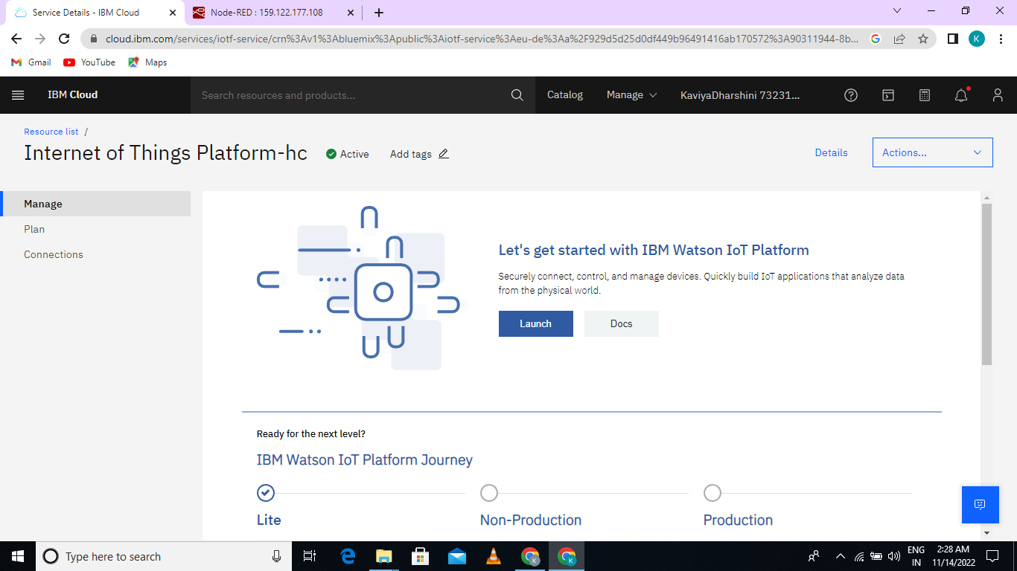

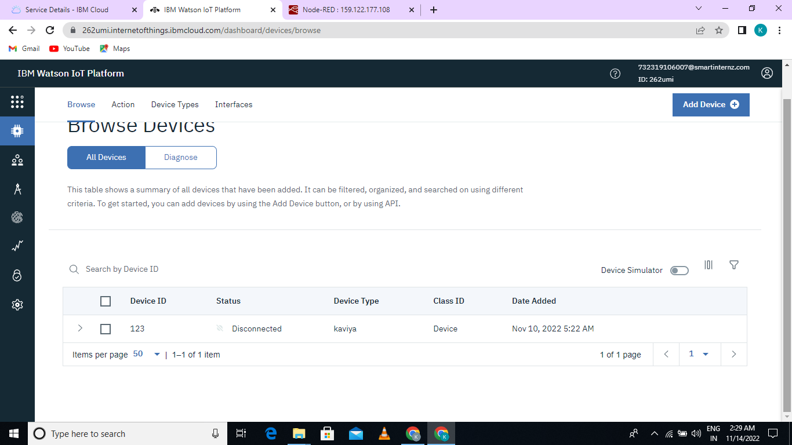

GO TO NODE RED PLATFORM AND ENABLE THE MANAGE PALLET:

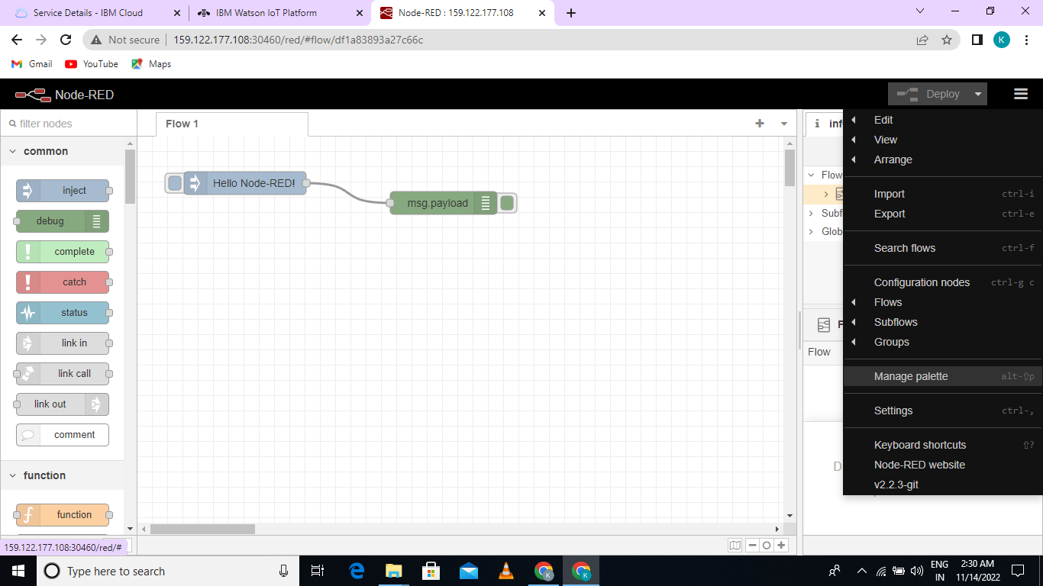

INSTALL PROCESS:

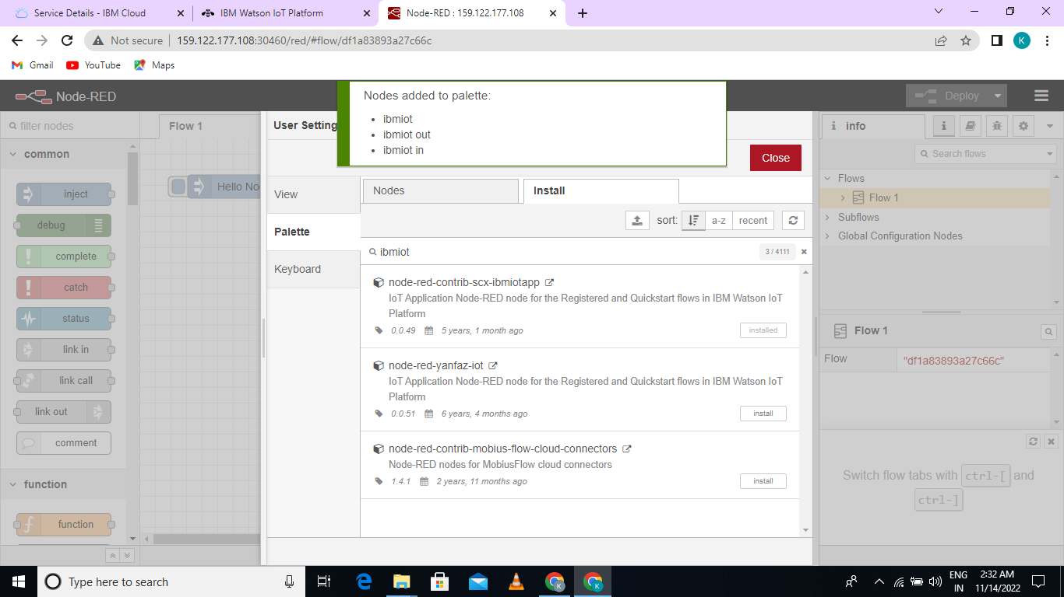

SET API KEY:

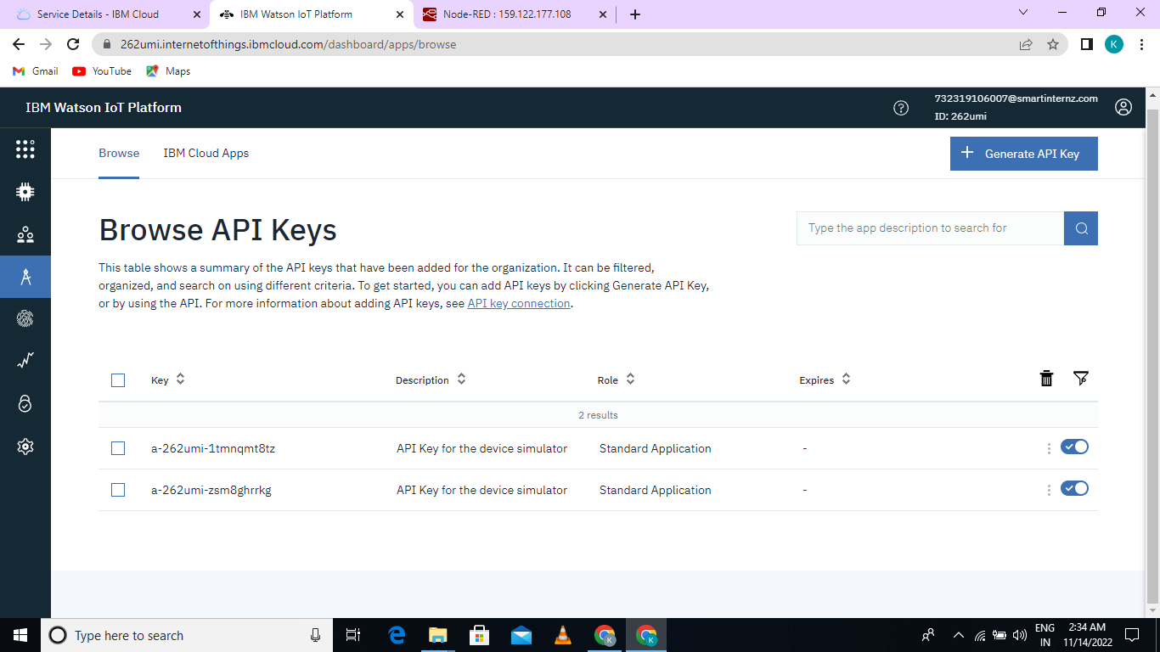

SET API KEY IN STANDARD MODE:

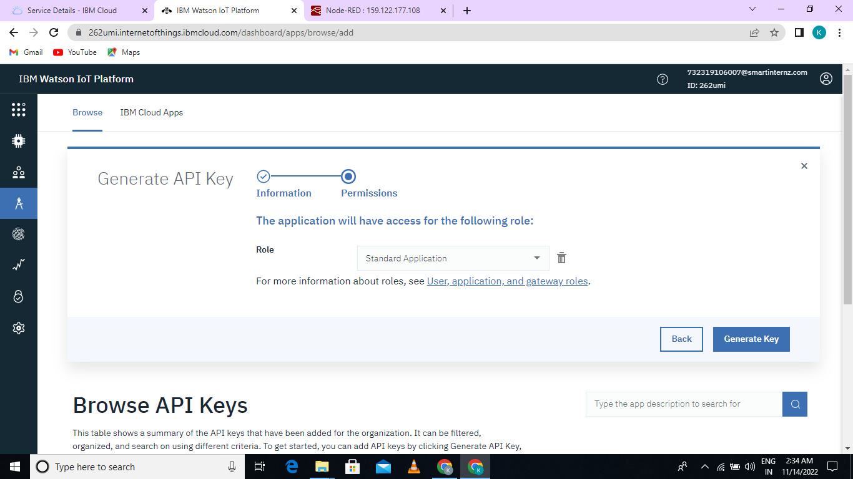

SET PROPERTIES:

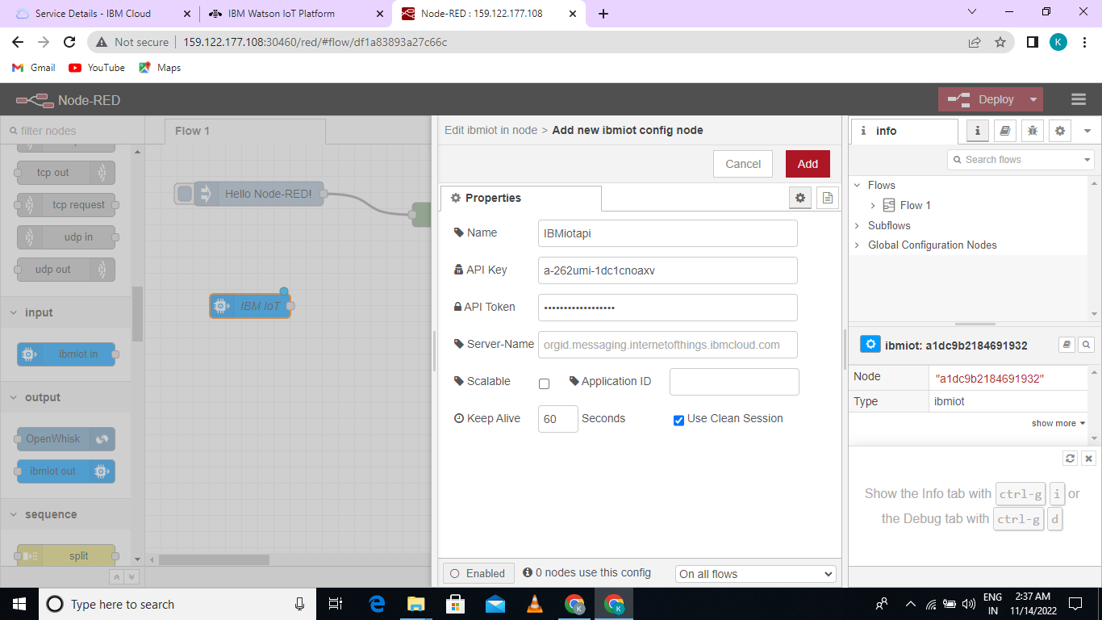

API KEY WAS SUCCESSFULLY ADDED:

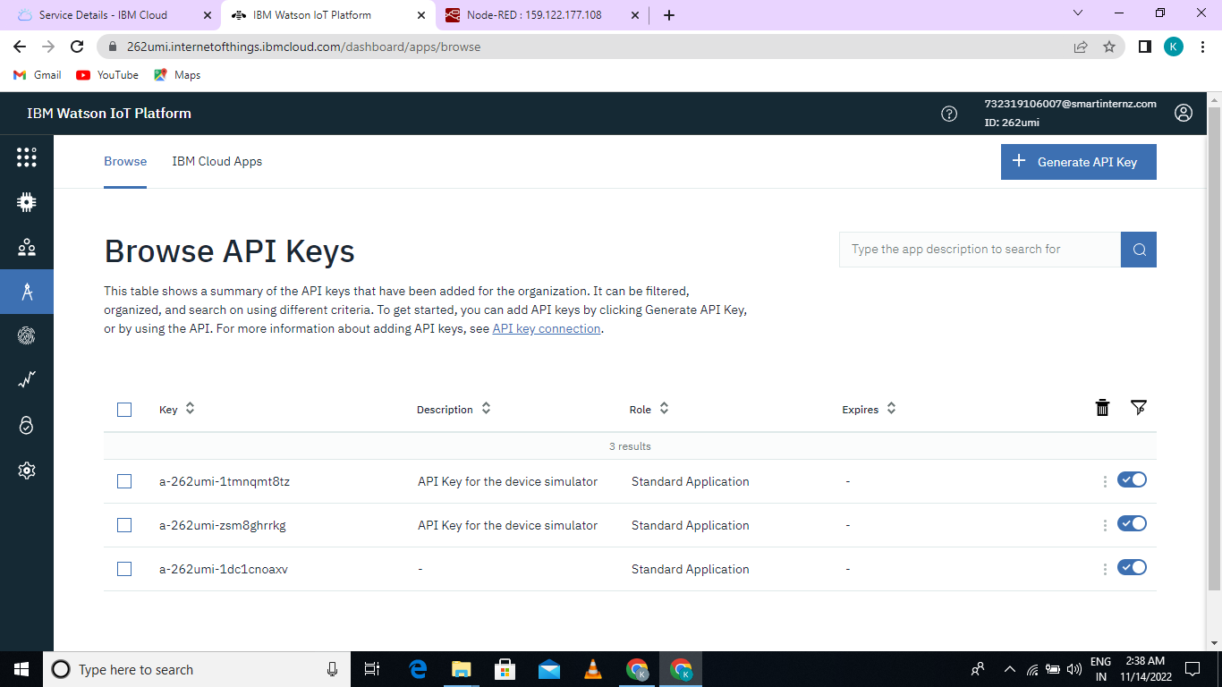

IN WOKWI DEVOLAPE A PROGRAM AND GENERATE OUTPUT:

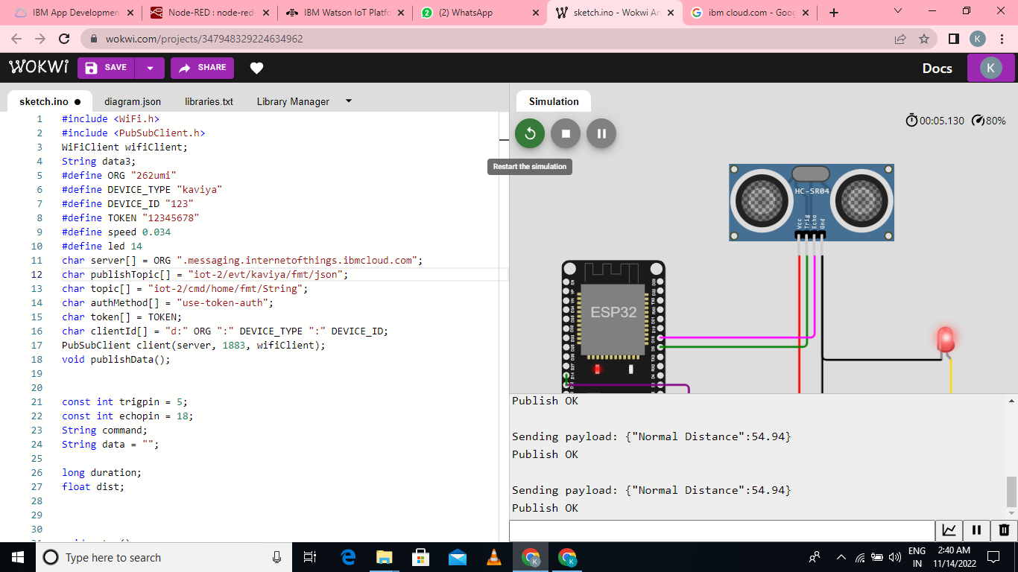

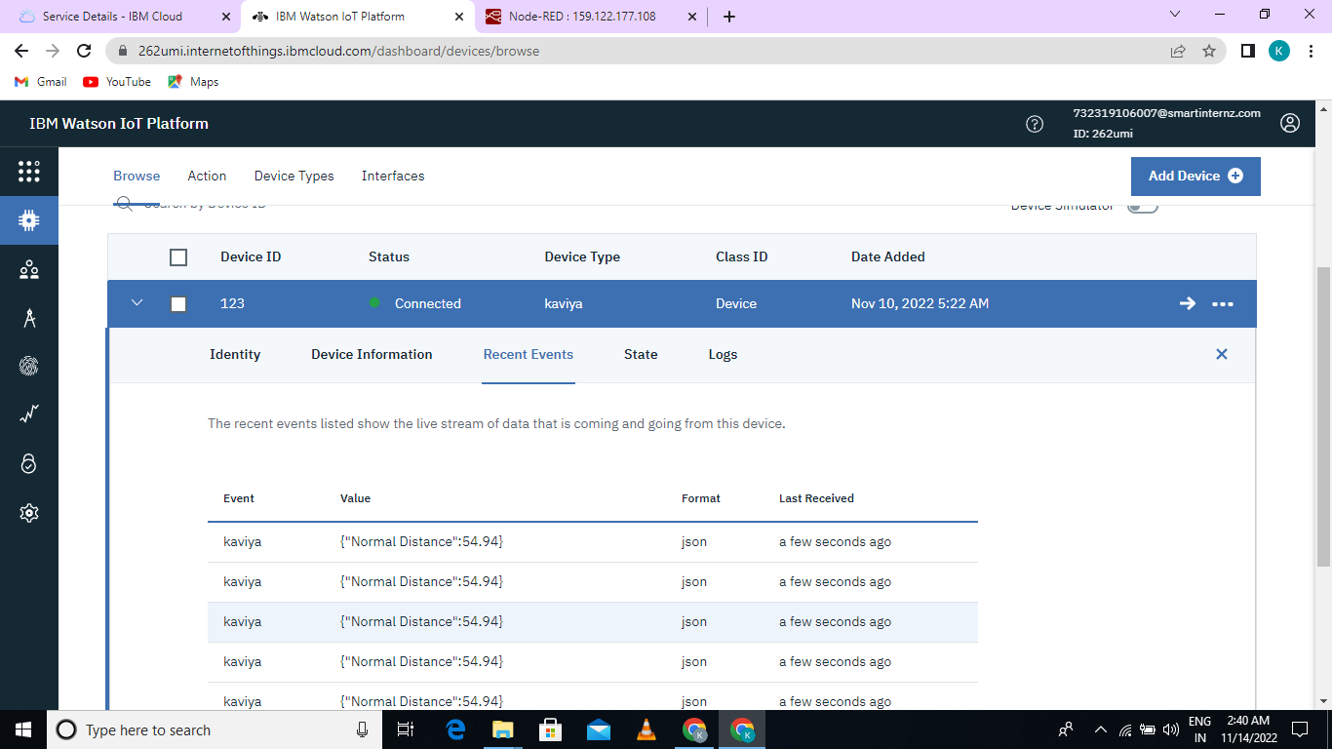

OUTPUT IN NODE RED:

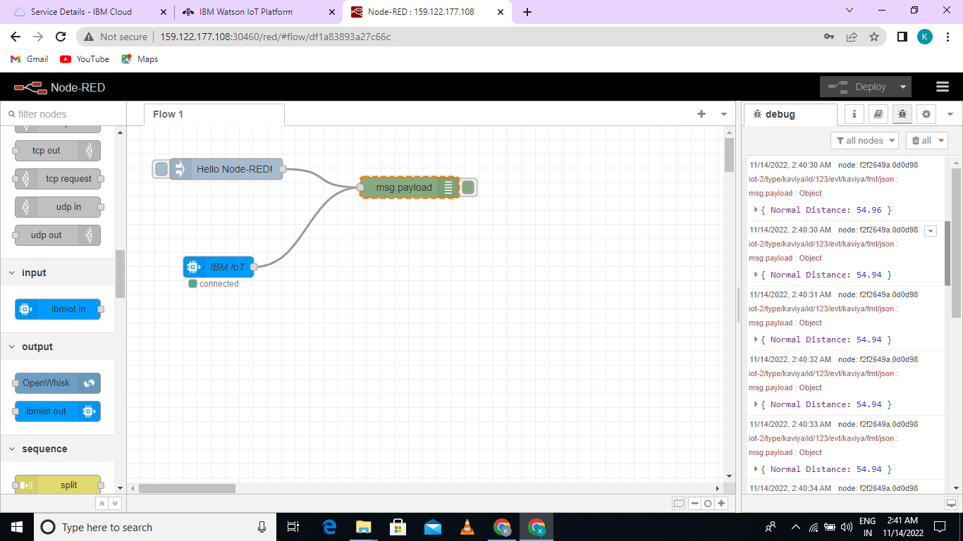

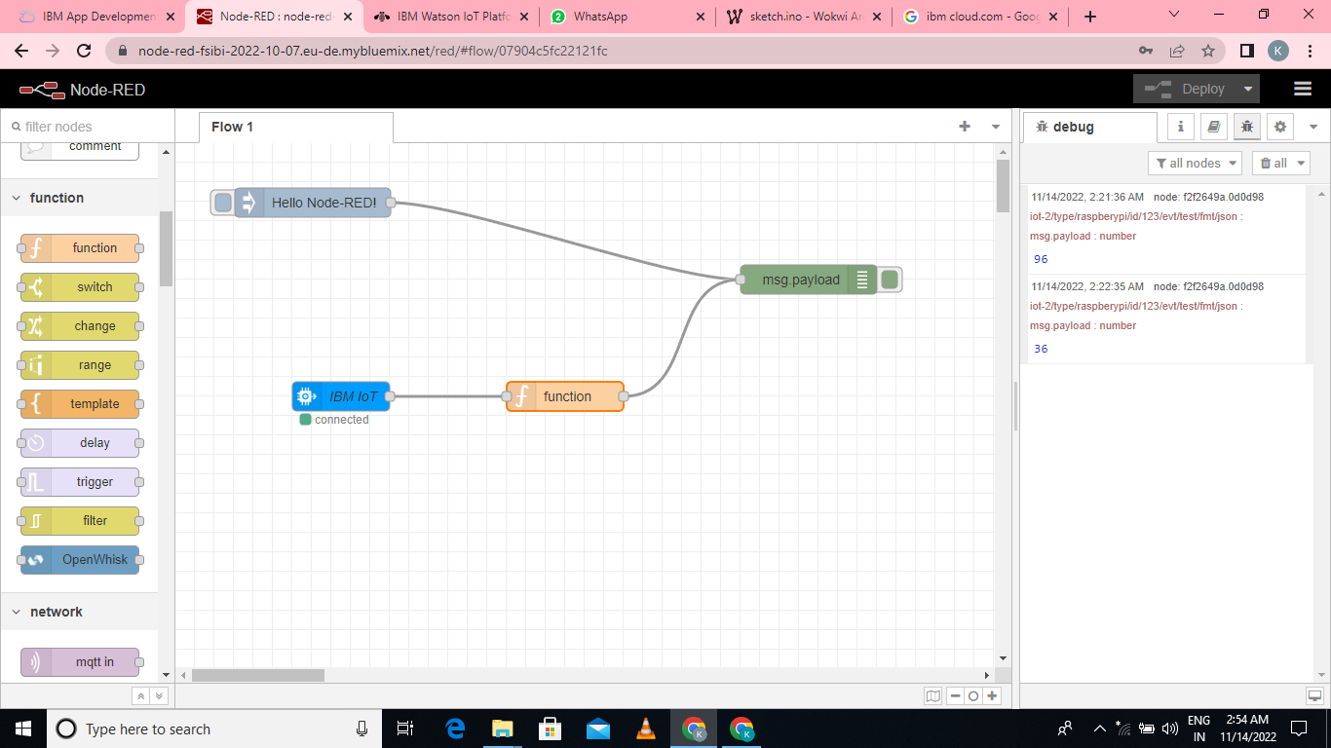

**DEVELOP A WEBSERVICE**:

